##################

# BOX PLOTS -#

##################

# Clear the workspace

**rm(list = ls())**

# NOTE:

# Uncomment the code lines wherever required (Ex: Package installation..)

# set the working directory: Recommended

# It will enable in keeping all the plots in one location.

# use setwd() & getwd() functions

# Install & load the package " ggplot2 "

# install.packages("ggplot2")

**library(ggplot2)**

**library(dplyr)**

# Plotting box plot using “orange” data set

# x axis we need factor data value and y axis integer value

# first need to convert the tree integer value into factor type using mutate

**df_TD <- data.frame(Orange)**

**View(df_TD)**

**factor(Orange$Tree)**

**df_TD <- mutate(df_TD, TreeNF = factor(Tree, order=TRUE, labels = c("A","B","C","D","E")))**

**View(df_TD)**

**ggplot2::ggplot(df_TD, aes(x=TreeNF,y=circumference))+**

**geom_boxplot()**

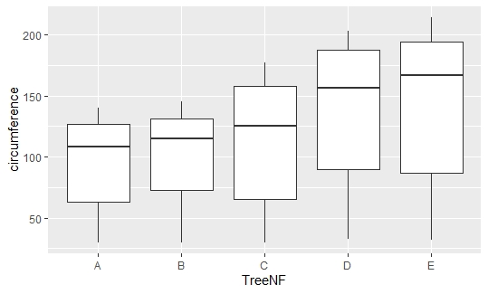

# flipping the graph side: horizontally

**data_boxplot <- ggplot2::ggplot(df_TD, aes(x=TreeNF,y=circumference))+**

**geom_boxplot()**

**data_boxplot + coord_flip()**

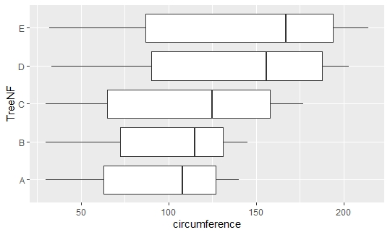

# marking the outliers, color the outlier points

**ggplot2::ggplot(df_TD, aes(x=TreeNF,y=circumference))+**

**geom_boxplot(outlier.color = "blue", outlier.size = 3)**



# Check out no outliers present in the plot

# Box plot with dots ( input data set as dots) Here, u can visualise no outliers

**ggplot2::ggplot(df_TD, aes(x=TreeNF,y=circumference))+**

**geom_boxplot(outlier.color = "blue", outlier.size = 3)+**

**geom_dotplot(binaxis = 'y', dotsize = 1)**

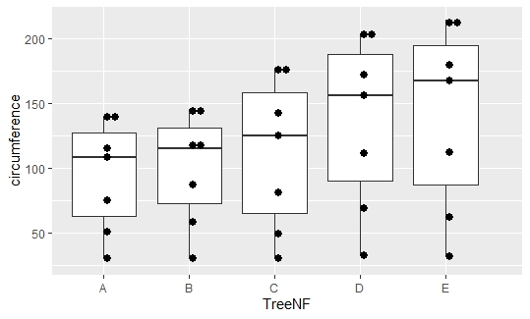

# Another Example: As Quick Review

# use package "ToothGrowth" mutate dose n use as X-axis, y-axis will be len

**df_TG <- data.frame(ToothGrowth)**

**factor(df_TG$dose)**

**df_TG <- mutate(df_TG, doseNF = factor(dose, order=TRUE, labels = c("0.5D","1.0D","2.0D")))**

**View(df_TG)**

**ggplot2::ggplot(df_TG, aes(x=doseNF,y=len))+**

**geom_boxplot(outlier.color = "red", outlier.shape = 2, outlier.size = 3)+**

**geom_dotplot(binaxis = 'y', dotsize = 1)**

